🧪 🌐 PROJECT: Web Server Deployment & Disaster Recovery
🎯 Objective
You will:
- Deploy a web server
- Host a website
- Take backups
- Simulate failure
- Recover system
👉 This is real-world DevOps work

🧱 Architecture (Simple)
User → Web Server (Apache) → Website Files
↓
Backup (tar)
↓
Restore (Disaster Recovery)

⚙️ Step 1: Install Web Server
Install Apache HTTP Server:
sudo apt update
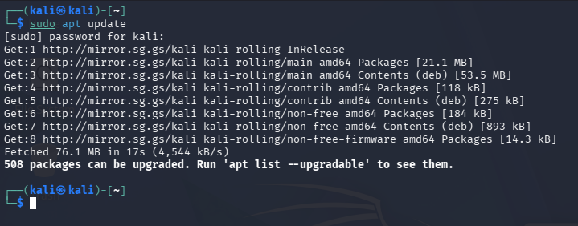
sudo apt install apache2 -y
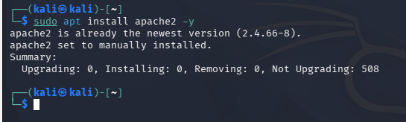
Start service:
sudo systemctl start apache2
sudo systemctl enable apache2
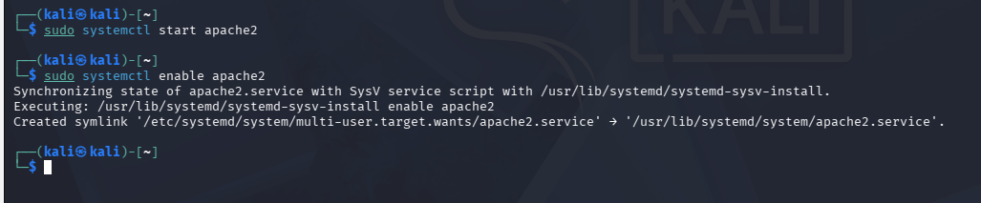

🌐 Step 2: Verify server
Open browser:
http://localhost
👉 You should see Apache default page
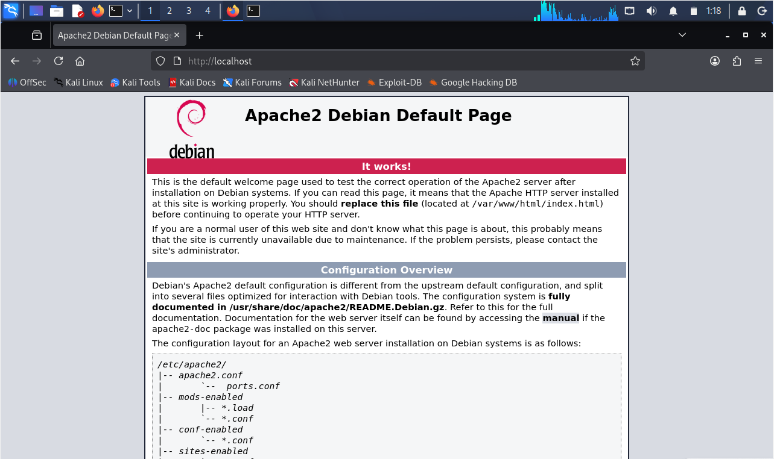

📄 Step 3: Deploy your website
Go to web directory:
cd /var/www/html
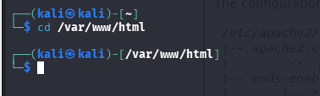
Create your page:
sudo nano index.html
Paste:
<h1>My DevOps Project 🚀</h1>
<p>Web Server is running successfully!</p>
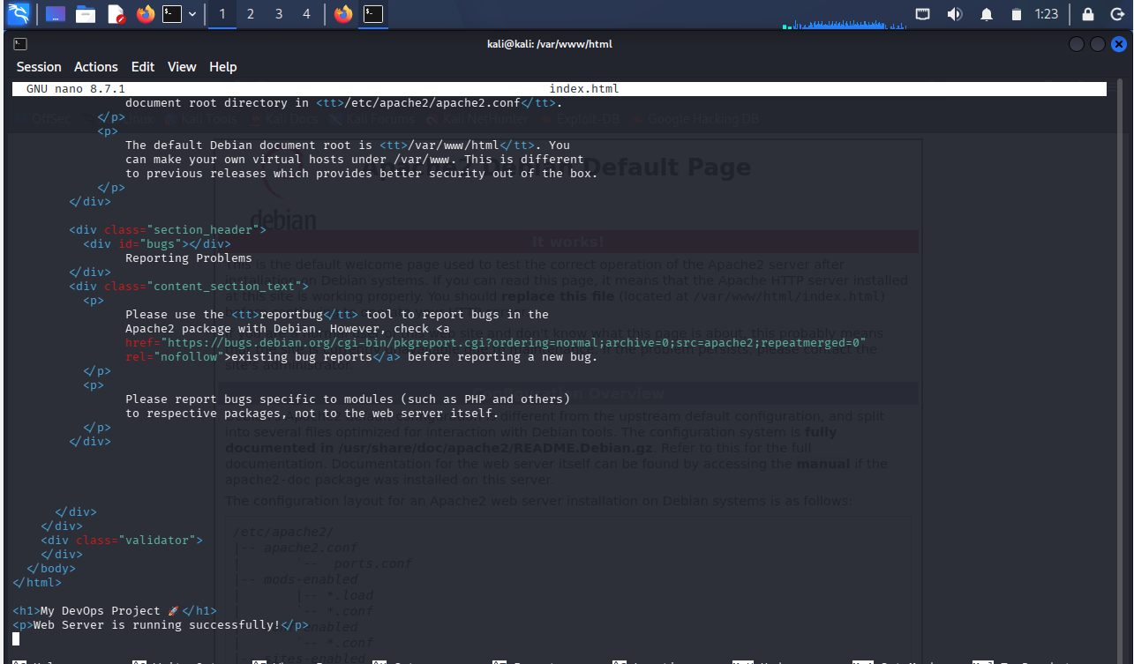

📦 Step 4: Take backup (IMPORTANT)
Go to root:
cd /
Backup website:
sudo tar -czvf web_backup.tar.gz /var/www/html
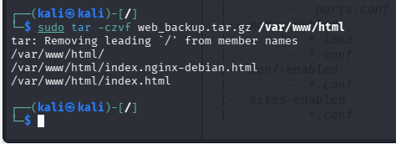

💥 Step 5: Simulate disaster
Delete website:
sudo rm -rf /var/www/html/*
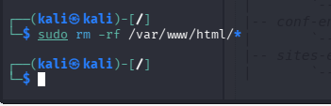
👉 Refresh browser → site gone ❌
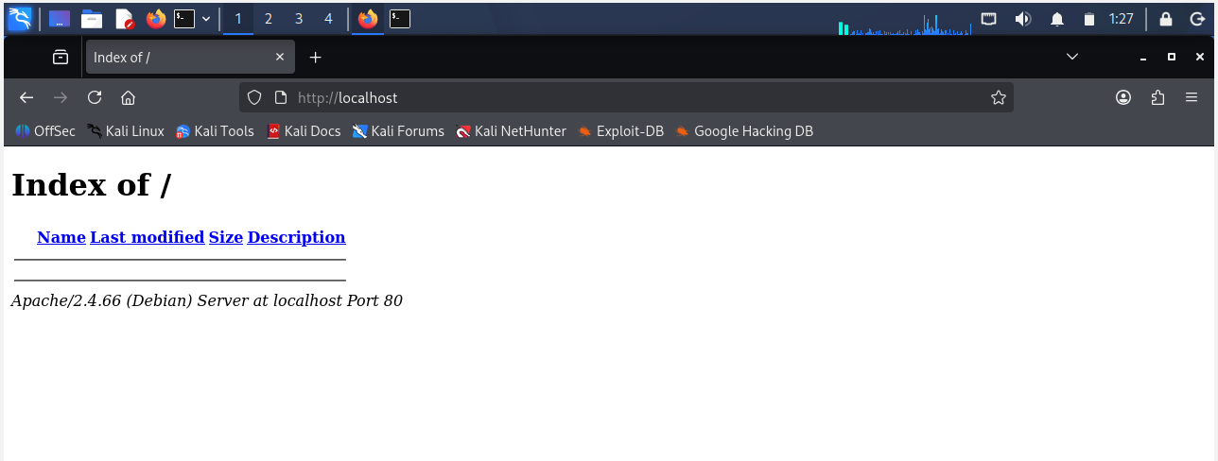

🔍 Step 6: Verify issue
ls /var/www/html
👉 Empty → confirmed failure

🔄 Step 7: Restore from backup
sudo tar -xzvf web_backup.tar.gz -C /
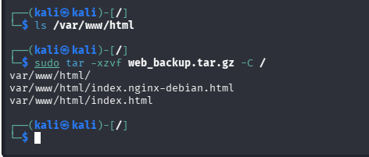

✅ Step 8: Verify recovery
Refresh browser:
👉 Website is back 🎉
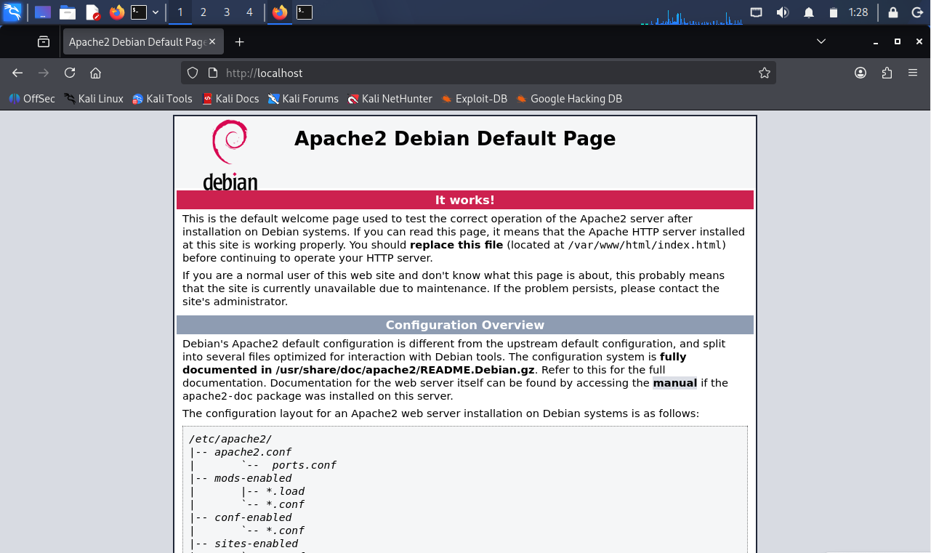

🔥 Step 9: Break service (Advanced)
Stop Apache:
sudo systemctl stop apache2
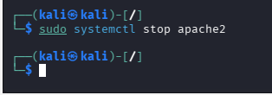

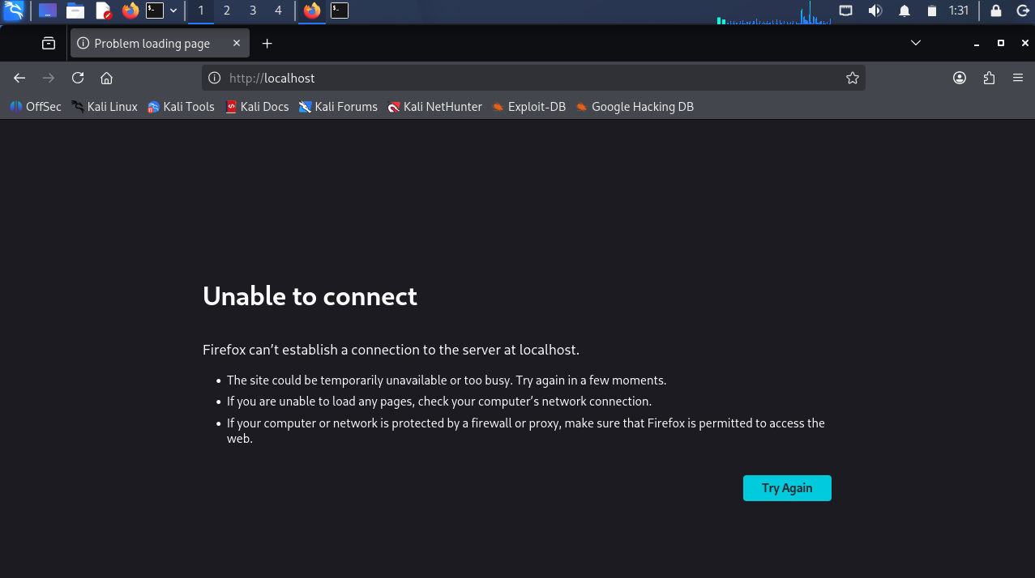
Check:
sudo systemctl status apache2
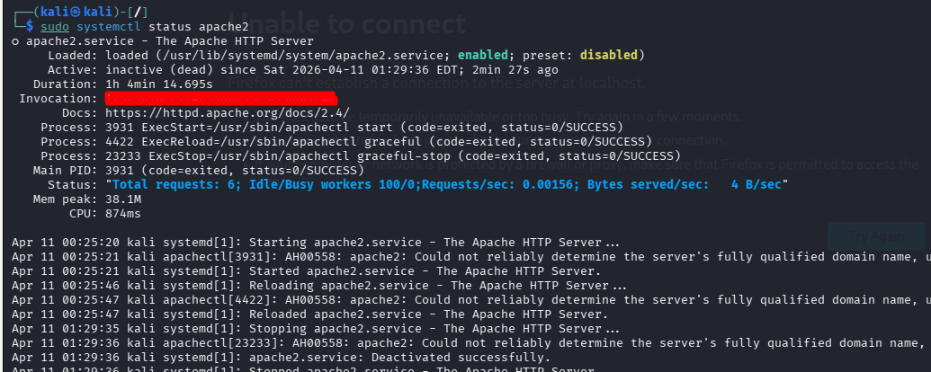

🔧 Step 10: Recover service
sudo systemctl start apache2

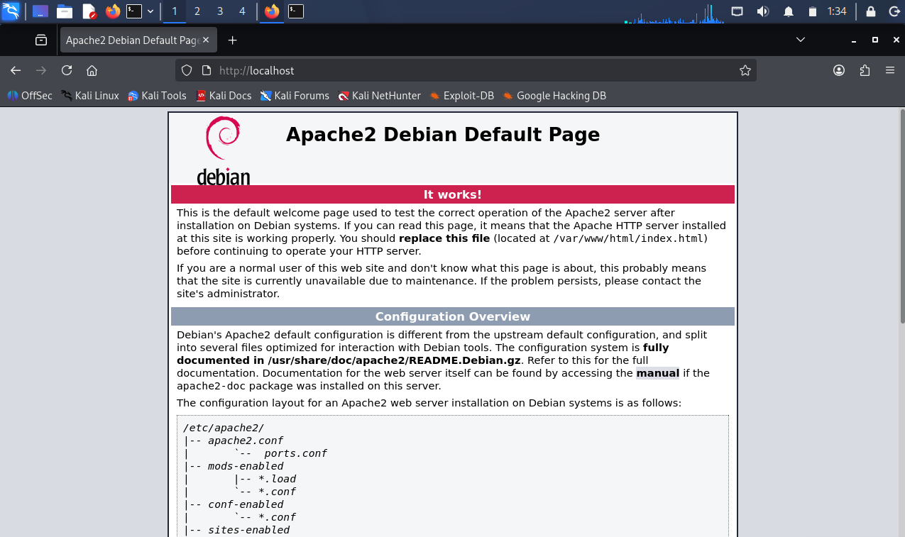

🧠 What you learned
- Web server deployment
- File hosting
- Backup using tar
- Disaster simulation
- Service recovery

